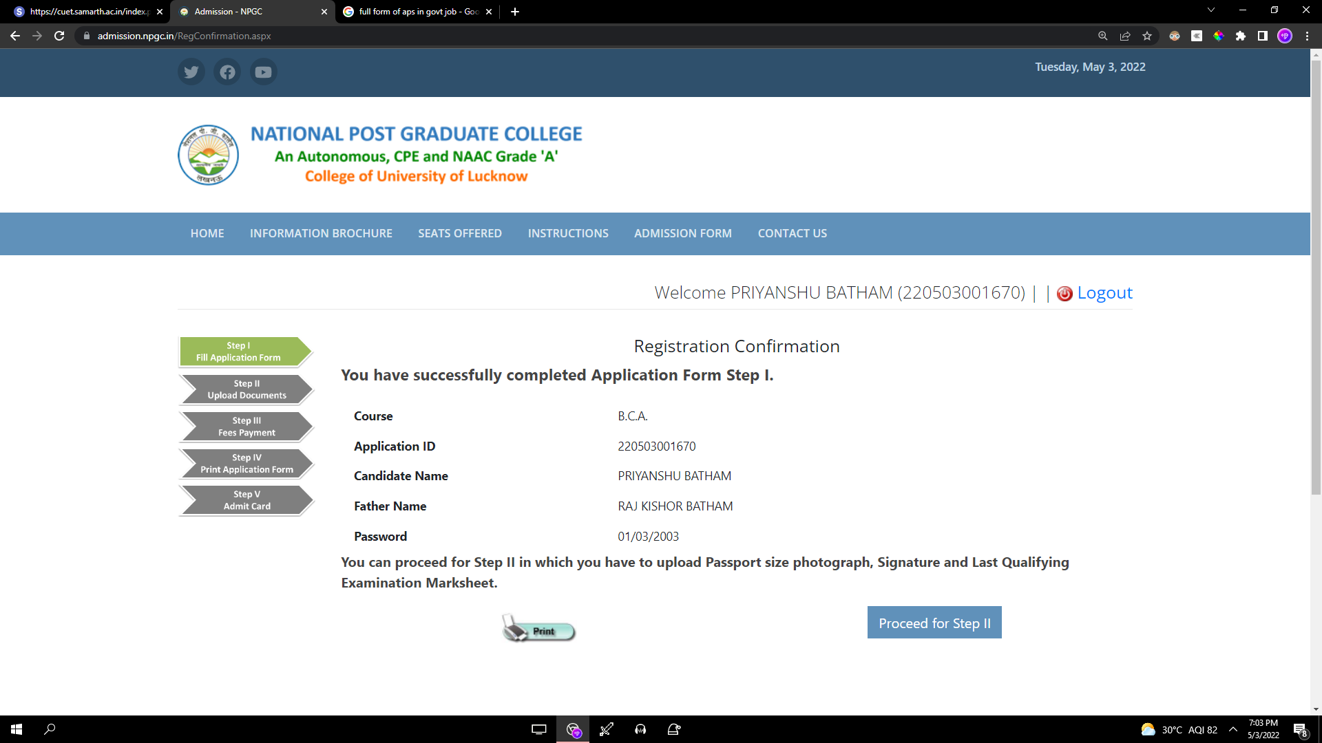

https://admission.npgc.in/PrintApplicationForm.aspx